Ensembles, applications, relations
Table des matières
Cours 2
Ensemble 2
Application 4
Injection, surjection, bijection 5
Relation 6
Méthode 7
Egalité d'ensembles 7
Applications injectives 7
Applications surjectives 7
Applications bijectives 7
Réciproque 7

Cours

Ensemble
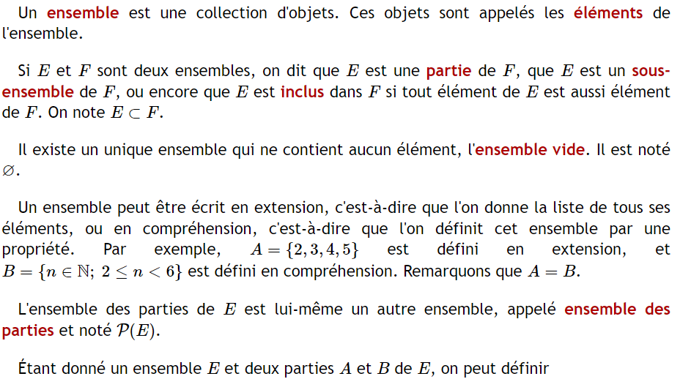

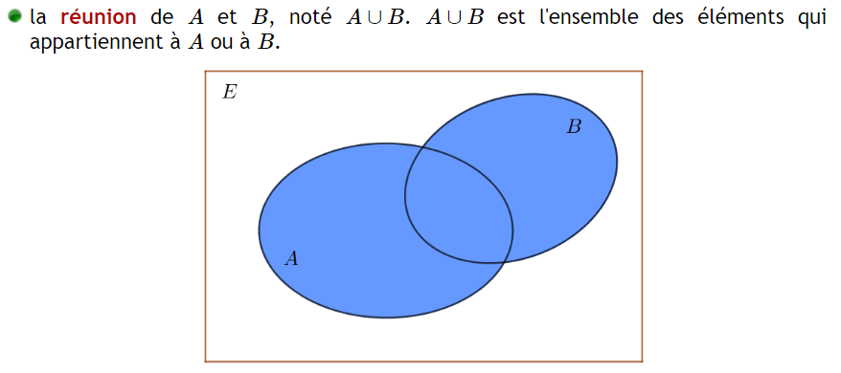

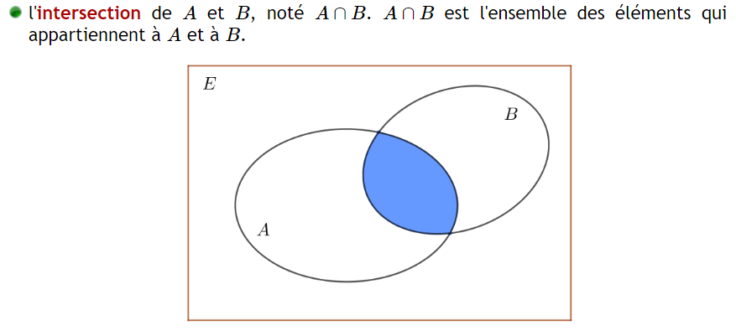
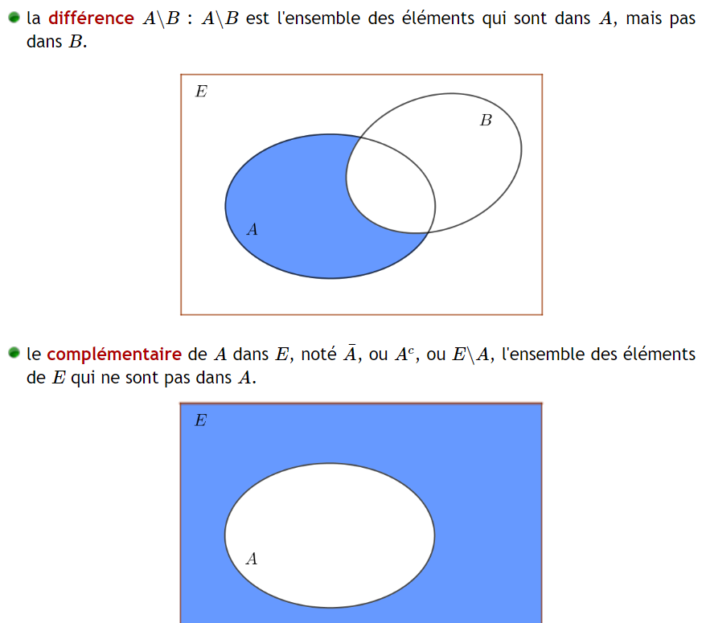
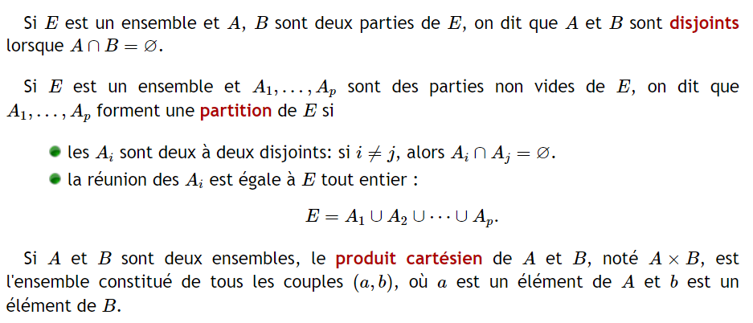

Application
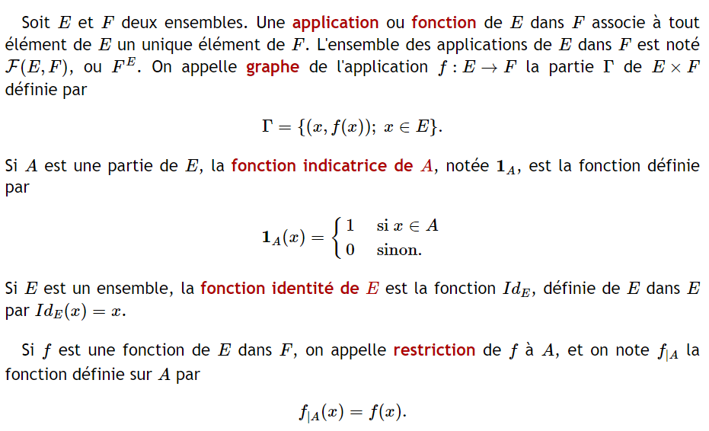
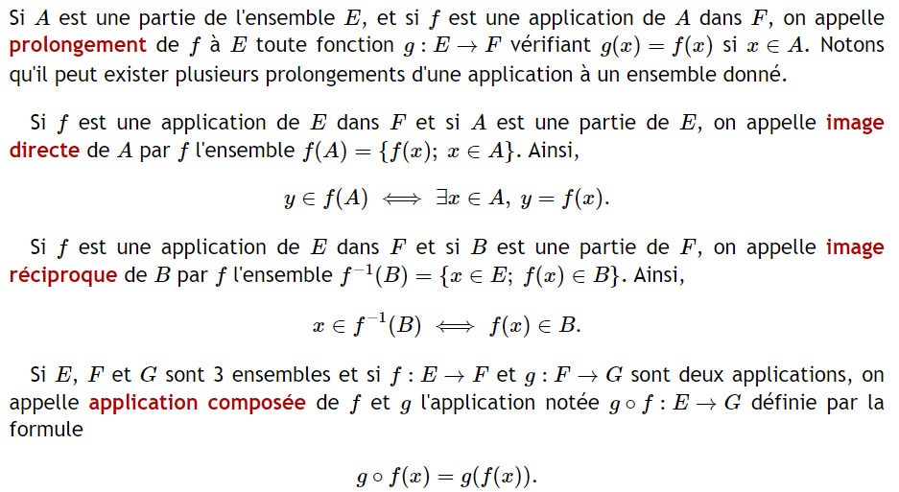

Injection, surjection, bijection
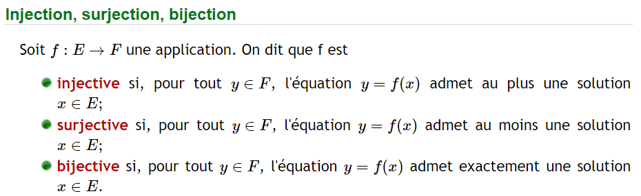
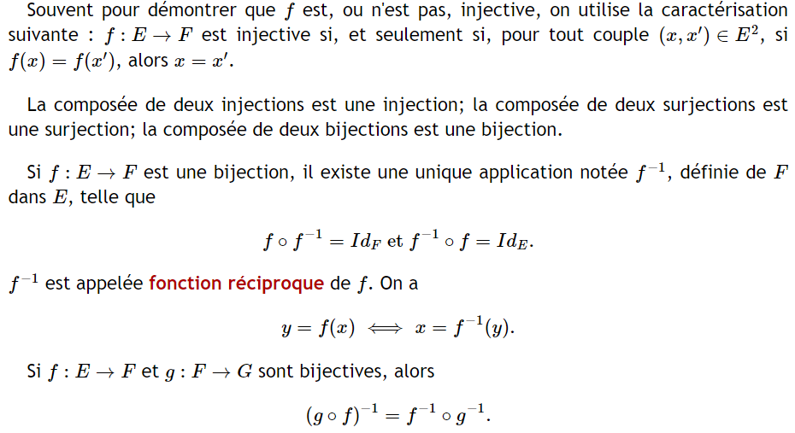

Relation
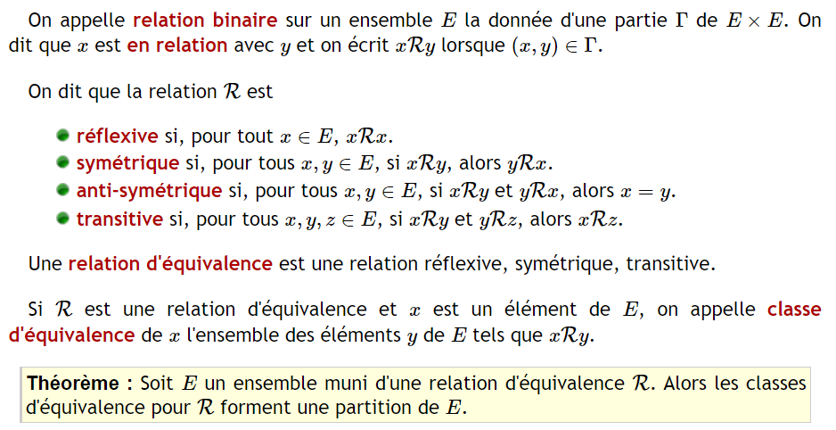
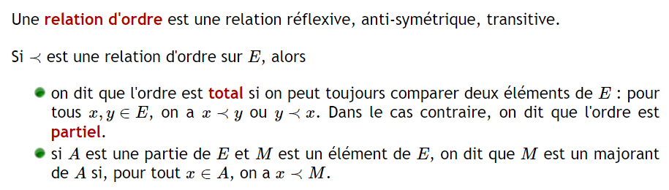

Méthode

Egalité d'ensembles

Applications injectives
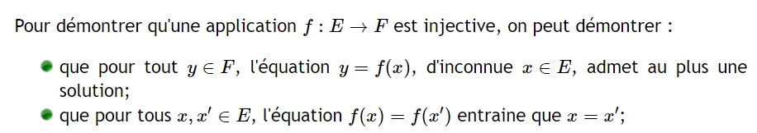

Applications surjectives

Applications bijectives
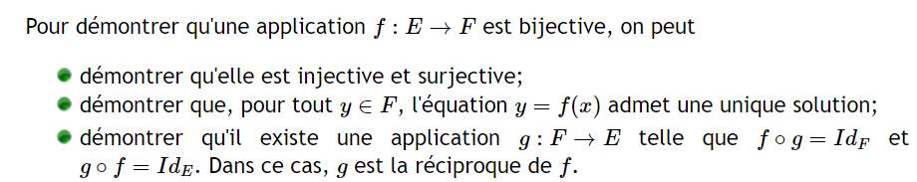

Réciproque
